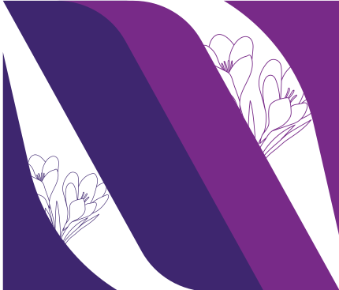
Nicole Downing
(937) 479-2226 | nicoledowning42@gmail.com | Instagram:@downing_design | https://www.nicole-downing.com/
Charge Artist Experience Set Designer Theater Date
Shining Girls Georgia Fried Ohio University 2023
We Are Proud To Present Princess Ibeh Vibrancy 2024
Assistant/Associate Designer Designer Theater Date

Yerma Hannah Carey Vibrancy 2023
Shining Girls Georgia Fried Ohio University 2023
Scenic Painter Set Designer Theater Date

Julius Caesar Christopher Rees Ohio University 2022
What The God’s Gave Me Georgia Fried Ohio University 2022
Hotel Berry David Russell Tantrum 2022
Carrie: The Musical Alex Pio Tantrum 2023
Yerma Hannah Carey Vibrancy 2023
Squeakers Zach Snow Ohio University 2023
Medea Princess Ibeh Ohio University 2023
The Knight of the Burning Pestle Lydia Ball Ohio University 2023
Twelfth Night Hannah Carey Tantrum 2023
Education School Year

Diploma Tippecanoe High School 2020
Bachelors of Fine Arts Ohio University 2024

The Scarefactory Inc. & Christmas Animatronic Magic September 3rd 2024- February 20th 2025
3D Artist/ Monster Makers Apprentice Columbus, Ohio
Williams Lea February 24th - Present
Presentation Designer Columbus, Ohio

Skills
Painting+ Drawing Digital Other

Advanced Sketching, Trompe L’oeil Vectorworks Valid Driver's License
Wood,Stone,Water Blender Valid Passport
Wood Grain Rocker Adobe Photoshop Typography
Rosco and Spray Paint Adobe Illustrator Mold Casting
Roller 3D Printing Prop Building
Color Matching Sketch Book Sewing/Fabrication
Perspective PowerPoint
Excel/Microsoft Word

- References upon request

